Brick Flicks - What movie posters or album covers are our Lego friends re-creating?
 | 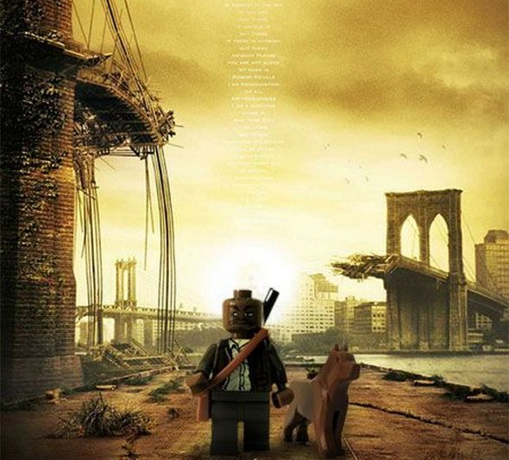
Bruce Springsteen – Born in the USA | I am Legend
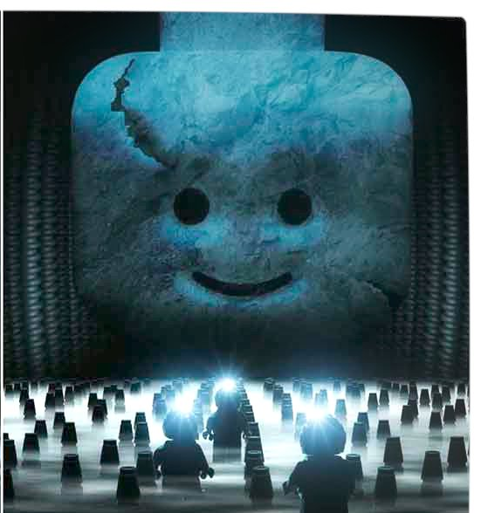 | 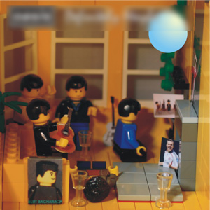
Prometheus | Oasis – Definitely Maybe
 | 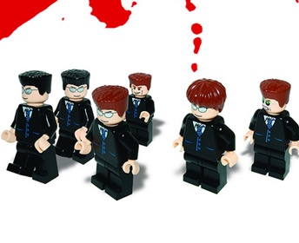
David Bowie – Aladdin Sane | Reservoir Dogs
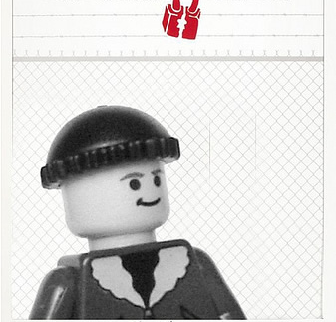 | 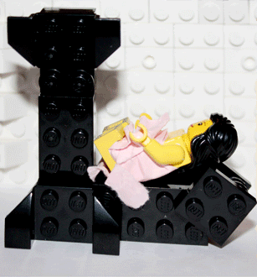
One Flew Over the Cuckoo’s Nest | Lily Allen – It’s not me, it’s you
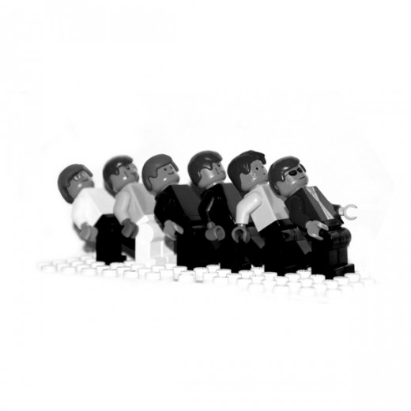 | 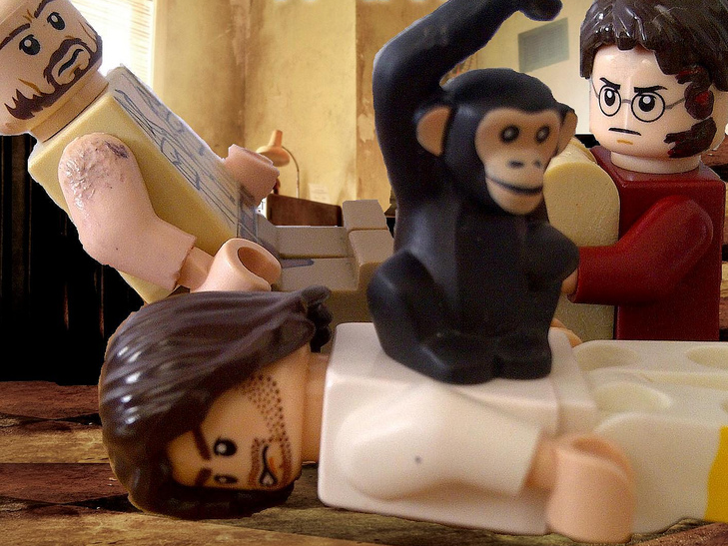
Madness – One Step Beyond | The Hangover – Part II

